

**KULLIYYAH OF INFORMATION & COMMUNICATION TECHNOLOGY**

**CSCI3302**

**SEMESTER 1, 2022/2023**

**SECTION 02**

**INDIVIDUAL PROJECT CODING**

**PREPARED BY: [INDIVIDUAL/GROUP NAME]**

|  |  |
| --- | --- |
| **NAME** | **MATRIC NO.** |
| MUHAMMAD YUSOFF JAMALUDDIN | 2016799 |

**LECTURER**

MADAM NURUL LIYANA BINTI MOHAMAD ZULKIFLI

CODE FROM THE PROJECT

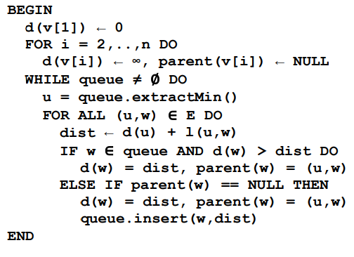

Figure 1 Code from the Project, it prioritizes Distance

The original code from the project prioritized distance from the user’s location and the destination.

MODIFIED CODE

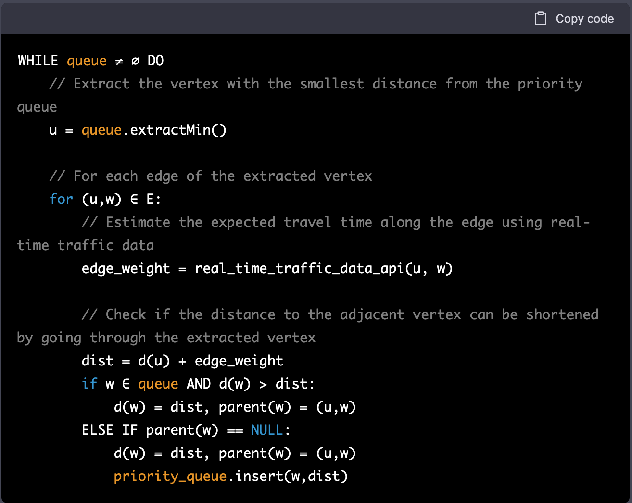

Figure 2 Code Modification to Priorities Real-Time traffic

The modified version prioritized real-time traffic value, this is because the patient depends on time not only the short distance between their current location and the destination to reach the donor.